SHOP API architecture of APIs

**Schemas:**

1. Product:

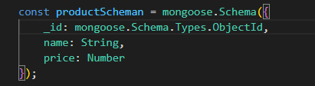

2. Orders:

This schema takes a unique ID for every order we make,

Apart from this, we’ll be taking productID, to refer to which product we’re making the order for, and the quantity considering the default value as 1.

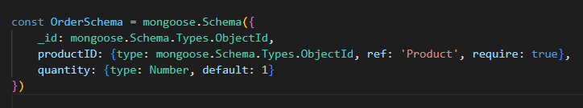

======================================================================

**Routes for multiple requests**

1. http://domainName.com/products/
2. POST:

We are using mongoose.Types.ObjectID() to assign a unique ID name to every product we’re posting using POST method